**FAQ extension**

1. **What is FAQ extension**

FAQ extension is a Magento extension that allow the admin manage the FAQ in his site. The extension allow admin not only manage group of FAQ but also manage the FAQ items, assign the FAQ in a specific store view, input media (image, widget…) into the FAQ. Moreover, the extension allow collect the feedback from the customer for a specific FAQ so that the admin can determine which FAQ should be displayed.

1. **Installation**

Copy and paste the whole source code of the extension into the source code of your site:

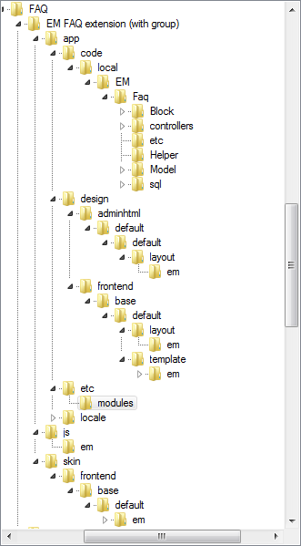

1. **Using**
2. Manage FAQ group:
3. Create new Group:

Go to **Admin > FAQ > FAQ Group Management**

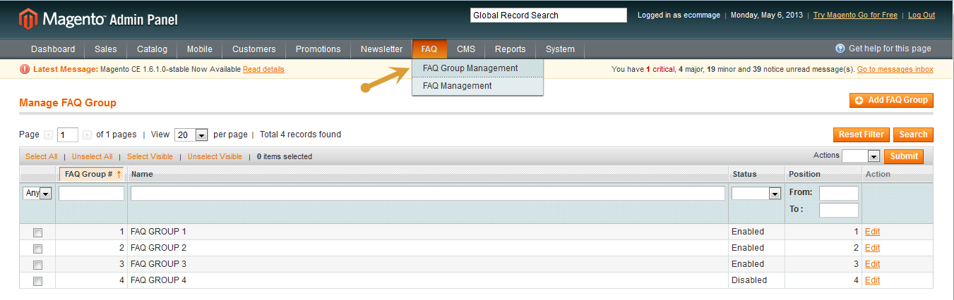

Click to Add FAQ Group to create new FAQ Group or click to an item in the grid view to read and edit the item

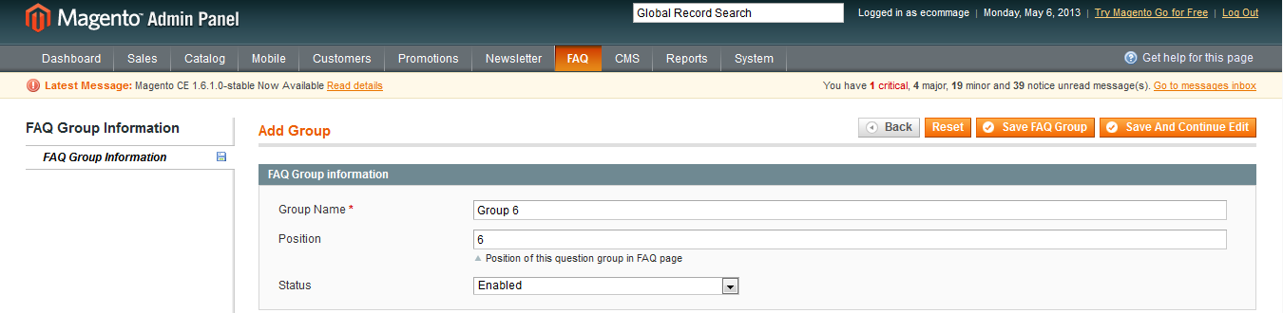

Click to “Save FAQ Group” or “Save And Continue Edit” to save the group.

1. Delete a group

You can choose multiple group to delete or delete a specific group in the edit page.

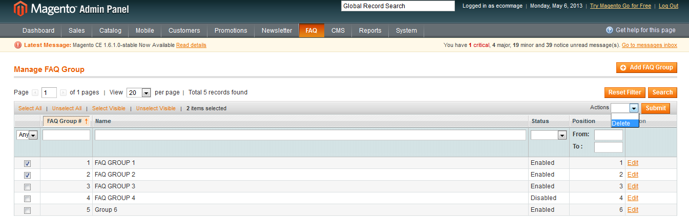

1. Mange FAQ
2. Create new FAQ

Go to **Admin > FAQ > FAQ Management**

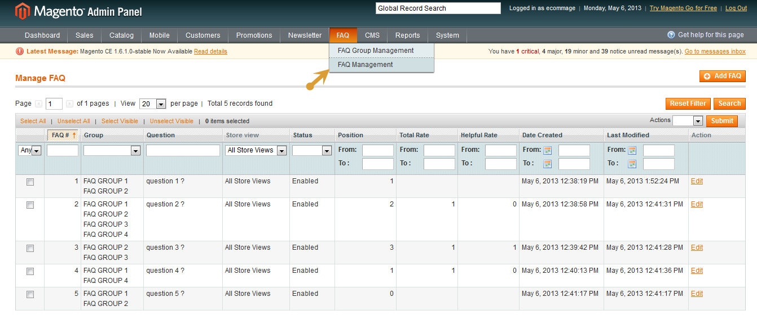

Click to Add FAQ to create new FAQ or click to an item in the grid view to edit the existing item

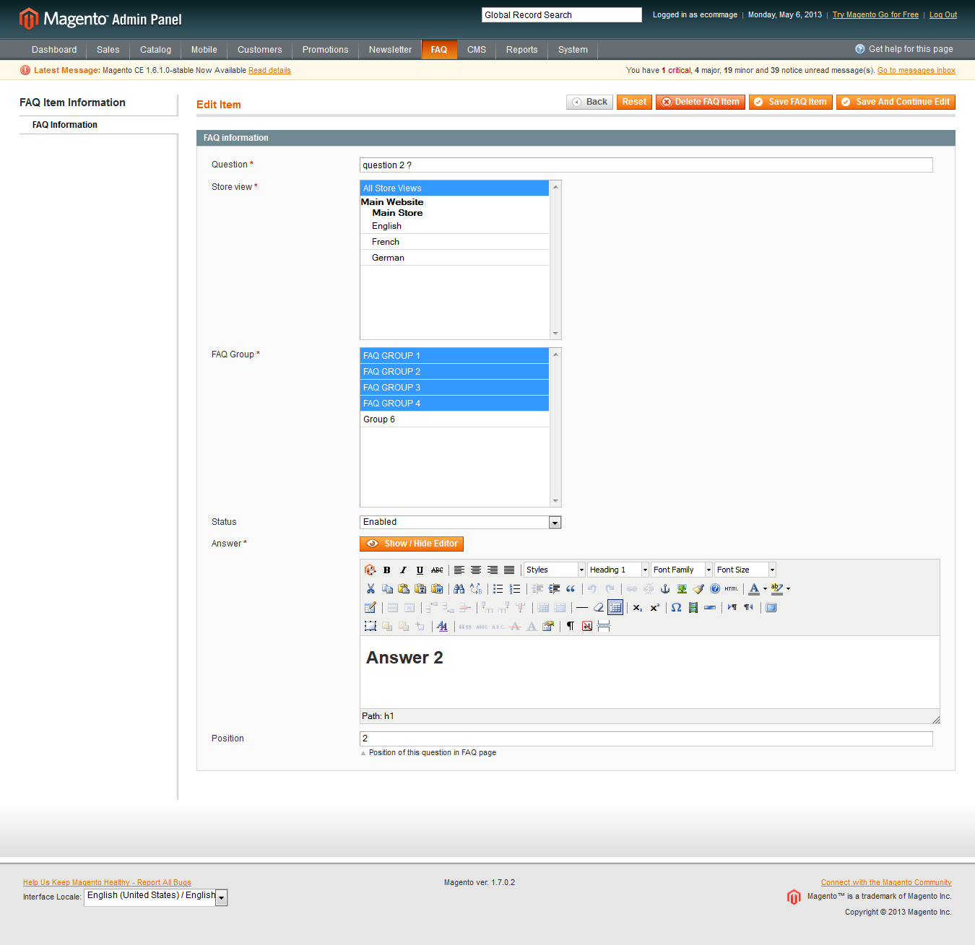

1. Delete a FAQ item

You can choose multiple FAQ to delete or delete a specific FAQ in the edit page.

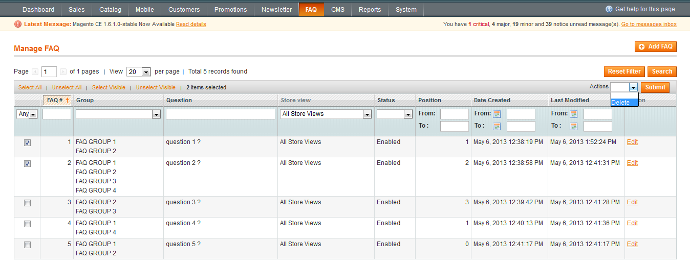

1. Display

The FAQ link on frontend is located in the footer link. This link redirect the customer to the FAQ page

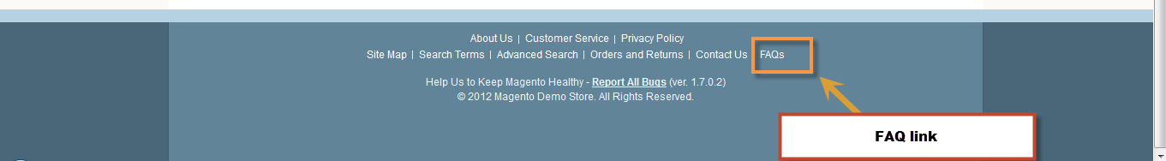

In FAQ page, the FAQs are display in their FAQ group. The customer can expand – collapse each item group

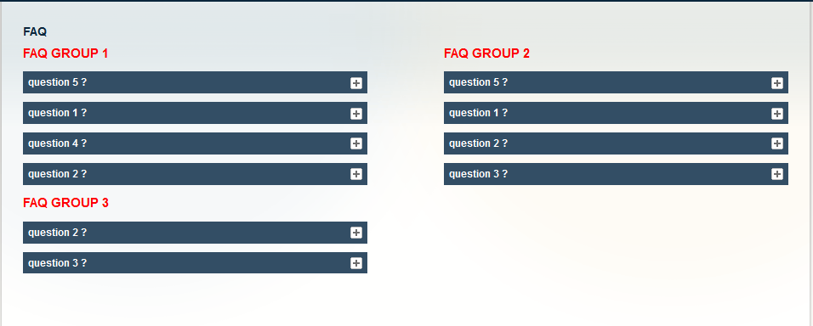

The customer can feedback for each FAQ item by click on the rate options

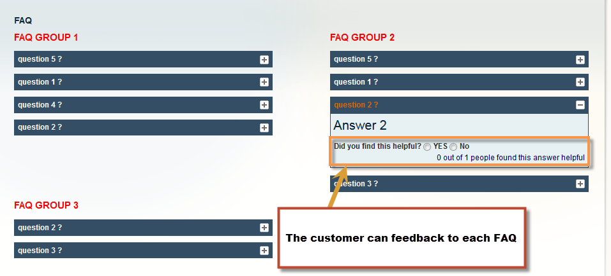

The customer’s feedback is displayed on the FAQ management page

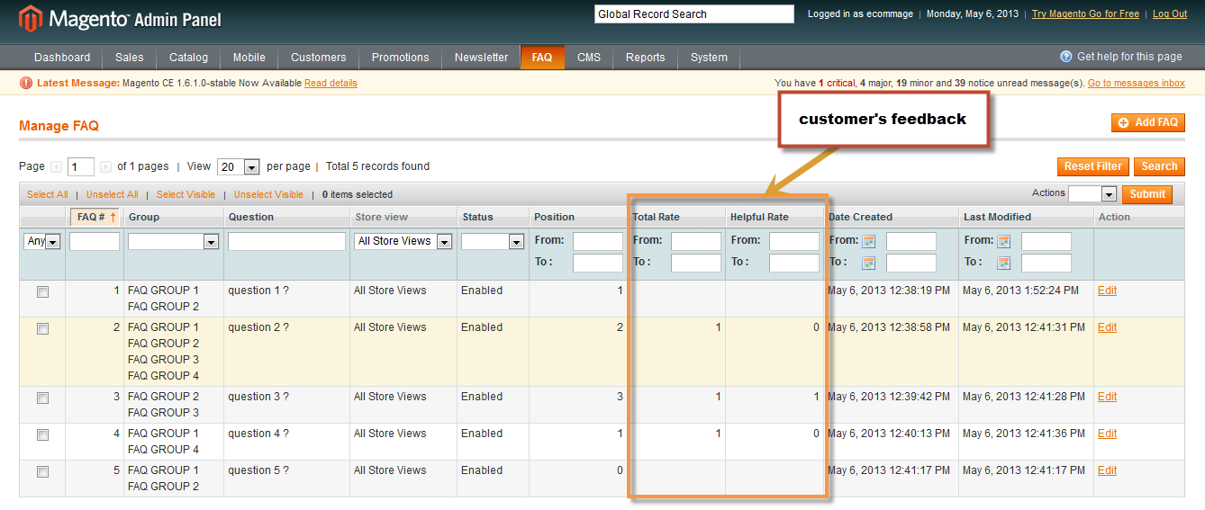

1. Enable – Disable

The extension has two options that allow the client **enable – disable** the whole extension or just the “did you find this helpful” function

